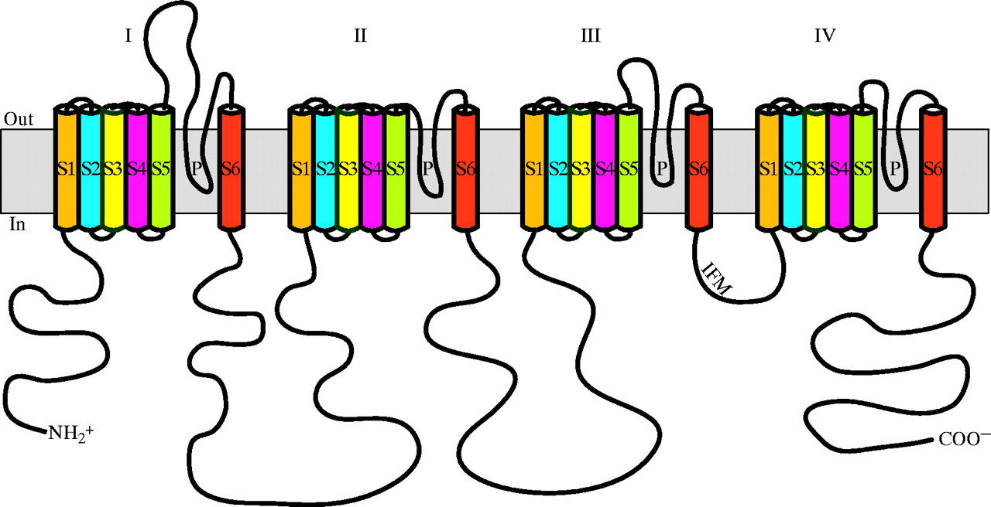

Protocol for cloning Voltage Gated Sodium Channels (Na Ch)

Zakon Lab, procedure of Ying Lu
---- University of Texas at Austin

1. Dissect organism to get desired tissue sample. Immediately freeze the tissue sample using liquid Nitrogen and then store at -80 degree Celsius.

2. Purify mRNA from tissue sample using RNA STAT-60 regent (TEL-TEST INC, 800-631-0600) or any other methods.

3. Amplify DNA from obtained mRNA starting at Domain IV by using either one of the two methods listed below:

One step method (using this method is quicker, but you need to perform the RT step again for other domains):

Use one step RT-PCR (Qiagen's OneStep RT-PCR kit) with degenerate primers:
Upper primer:
GenX5C (TVYTBGTNTGYYTVATHTTYTGG) (DIII, S5)
Lower primer:
D4L1 (TCYARRATVAYRGCDATRTACAT) (DIV, S6)

2nd round of PCR use:
Upper primer:
GenY5C (AAAGGNTGGATGGRNATHATGTA) (DIII, S5-S6)
Lower primer:
D4L2 (ARRAANSANAHRAYRATRTAVMT) (DIV, S6)

Two step method (this method allows you to get a longer strand of cDNA which you can use again in later steps):

Perform reverse transcription to get cDNA (Invitrogen's Superscript II RNase H-Reverse transcriptase)
using Primer
D4RT: (AASVWNWCRAARTCDTCYTC) (afterDIV, S6)

1st round of PCR (TaKaRa Taq) use:
Upper primer:
GenX5C (TVYTBGTNTGYYTVATHTTYTGG) (DIII, S5)
Lower primer:
D4L1 (TCYARRATVAYRGCDATRTACAT) (DIV, S6)

2nd round of PCR use:
Upper primer:
GenY5C (AAAGGNTGGATGGRNATHATGTA) (DIII, S5-S6)
Lower primer:
D4L2 (ARRAANSANAHRAYRATRTAVMT) (DIV, S6)

4. Run electrophoresis gel using products from both rounds of PCR. Cut the correct band based on size and purify the DNA from the cut of gel sample using Qiagen's Gel Extraction kit.

5. Clone the purified DNA from the previous step using Invitrogen's TOPO TA Cloning kit.

6. From the bacterial growth on the plates from step 5, select the colonies and grow in test tubes with LB + antibiotics. Make sure to grow several colonies of bacteria overnight.

7. Perform purification and extraction using Eppendorf's Perfectprep Plasmid Mini, or any other technique to get plasmid DNA.

8. For each of the samples, mix: 4 uL of plasmid DNA, 1 uL buffer 3, 1 uL EcoRI, 4uL H₂0. Incubate mixture at 37 degree Celsius for 1 hour. This is to check the size of DNA inserted.

9. Run electrophoresis gel using the digested DNA from step 8. Look at the sizes of bands and determine which sample contains the desired DNA.

10. Send some of the plasmid DNA sample obtained in step 7 to the sequencing lab along with the T7 or M13 primers.

11. After obtaining the sequence of D4 you can design specific lower primers in order to extent the sequence into DII and DI.

The degenerate primers needed are as followed:

DomainII upper primers (Choose most appropriate starting place for you sequence):

Starting at the end of DII:
1st round of PCR:
Ster1C1b (GCCATCRTYRTCTTCATCTT) (DII, S5)
2nd round of PCR:
Ster1C2b (GAYTTCTWCCACTCCTTCCT) (DII, S5-S6)

Starting at the beginning of DII:

1st round of PCR:
Ster2DU1 (ATNGTNATGGAYCCNTTY) (DII, S1)
2nd round of PCR:
Ster2DU2 (TTYATGKCNMTGGARCAYYA) (DII, S1)

Domain I upper primers:
1st round of PCR:
D1U1c (TRAARRYHATYGTBGGNGCYYT) (D1, S4)
2nd round of PCR:
D1U2 (AAGMARMTSNBDGAYGTSATGA) (DI, S4-S5)

12. If you have the correct sized PCR products, re run gel and cut out the correct band. Then purify the DNA and send the purified PCR sample directly to the sequencing lab with the specific primers.

